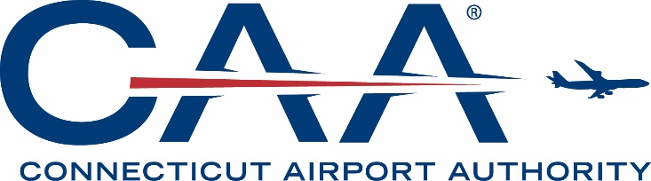

NOTICE OF SPECIAL MEETING AND AGENDA

CONNECTICUT AIRPORT AUTHORITY
AUDIT COMMITTEE MEETING

Tuesday, October 8, 2019, at 3:00 pm
Bradley International Airport – Third Floor Conference Room

- Call to Order.

- Approval of Minutes:

- August 21, 2019 Audit Committee Meeting.

- Discussion Item:

- Discussion of Financial Statements (Audit) for Fiscal Year Ending June 30, 2019.

- Adjournment.

