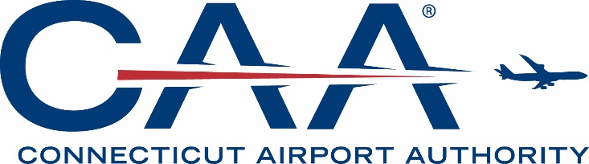

AGENDA

CONNECTICUT AIRPORT AUTHORITY
AUDIT COMMITTEE MEETING

Wednesday, August 21, 2019, at 1:00 pm
Bradley International Airport – Third Floor Conference Room

- Call to Order.

- Approval of Minutes:

- October 16, 2018 Audit Committee Meeting.

- Discussion Item:

- Discussion of Financial Statements (Audit) for Fiscal Year Ending June 30, 2019.

- Action Item:

- Consideration of and Action Upon Approval of an Uncollectible Receivables Write-off Policy.

- Adjournment.

