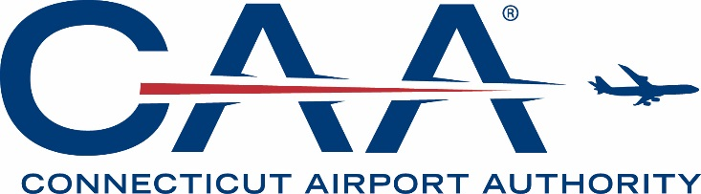

AGENDA

CONNECTICUT AIRPORT AUTHORITY
BOARD MEETING

Wednesday, May 15, 2019, at 1:00 pm
Bradley International Airport – Third Floor Conference Room

- Call to Order.

- Welcome Remarks (Tony Sheridan)

- Approval of Minutes:

- April 15, 2019 Board Meeting.

- Executive Director’s Report.

- Discussion Items:

- Discussion of Board Meeting Schedule.
- Discussion of Organizational Marketing Plan.

- Committee Reports:

- Finance and Operations Committee (Brett Browchuk)
- Economic Asset Development Committee (Scott Guilmartin)

- Finance and Operations Committee:

Consent Items:

- Consideration of and Action Upon Approval of Fiscal Year 2020 Operating and Capital Budgets – Bradley International Airport.
- Consideration of and Action Upon Approval of Fiscal Year 2020 Operating and Capital Budgets – General Aviation Airports.
- Consideration of and Action Upon Granting the CAA Executive Director the Authority to Reallocate FY 19 Bradley Budget Dollars Between Reporting Line Items.
- Consideration of and Action Upon Granting the CAA Executive Director the Authority to Reallocate FY 19 GA Airports Budget Dollars Between Reporting Line Items.

- Executive Session:

- Discussion of Potential Acquisition of Other Airports (Negotiating Strategy Regarding Potential Acquisition or Lease of Property).
- Discussion of Air Service Development (Negotiating Strategy Regarding Potential Acquisition or Lease of Property).

- Next Board Meeting:

- Discussion of Agenda Topics.

- Adjournment.

